

**Tribhuvan University**

**Faculty of Humanities and Social Sciences**

**Face Recognition Based Attendance System**

**A PROJECT REPORT**

**Submitted to**

**Department of Computer Application**

**NIMS College**

***In partial fulfillment of the requirements for the Bachelors in Computer Application***

Submitted by

Raj Kumar Karki

Reg. No. : 6-2-756-8-2019

2023/05

**Under the Supervision of**

**Bikash Thapa Magar**



**Tribhuvan University**

**Faculty of Humanities and Social Sciences**

**NIMS College**

**Supervisor’s Recommendation**

I hereby recommend that this project prepared under my supervision by Raj Kumar Karki entitled “**Face Recognition based Attendance System”** in partial fulfillment of the requirements for the degree of Bachelor of Computer Application is recommended for the final evaluation.

-----------------------

**SIGNATURE**

Bikash Thapa Magar

**SUPERVISOR**

Coordinator

BCA Department

Kanibahal Lalitpur, Nepal



**Tribhuvan University**

**Faculty of Humanities and Social Sciences**

**NIMS College**

**LETTER OF APPROVAL**

This is to certify that this project prepared by Raj Kumar Karki entitled “Face Recognition based Attendance System**”** in partial fulfillment of the requirements for the degree of Bachelor in Computer Application has been evaluated. In our opinion it is satisfactory in the scope and quality as a project for the required degree.

|  |  |
| --- | --- |
|  |  |
| **SIGNATURE of Supervisor** | **SIGNATURE of HOD/ Coordinator** |
| Bikash Thapa Magar,  BCA Coordinator | Shyam Thapa Magar  College Coordinator |
| BCA Department | BCA Department |
| Kanibahal Lalitpur, Nepal | Kanibahal Lalitpur, Nepal |
|  |  |
| **SIGNATURE of Internal Examiner** | **SIGNATURE of External Examiner** |
| **Internal Examiner** | **External Examiner** |

# Abstract

We are living in a world where everything is automated and linked online. The internet of things, image processing, and machine learning are evolving day by day. Many systems have been completely changed due to this evolve to achieve more accurate results. The attendance system is a typical example of this transition, starting from the traditional signature on a paper sheet to face recognition. This Project proposes a method of developing a comprehensive embedded class attendance system using facial recognition with showing whether the face of the person is the students for the specified class or not. The system is based on the machine learning algorithm which is to be implemented on python language and using computer/laptop camera for the input image of the students or a normal outer camera can also be used which has to be connected to the system which is programmed to handle the face recognition by implementing the Local Binary Patterns algorithm LBPs.

***Key Words: Face detection, Face Recognition, spreadsheet, OpenCV, Tkinter GUI***

# 

# Acknowledgement

This project was successful with the help of many people. So, I would like to thank all those who helped me to complete this project.

Firstly, I would like to express my special thanks of gratitude to TU (Tribhuvan University) and NIMS college who gave me the golden opportunity to do this project on the topic Face Recognition based Attendance system. Then I will thank Teacher (Bikash Thapa Magar) under whose guidance I have learned a lot about this project and developed an excellent project. His suggestions and directions have helped me a lot to complete this project. He motivated and corrected me while I have errors in my projects. He helped me in doing a lot of Research and i came to know about a lot of things related to this topic.

At last, I would like to thank my parents for their excellent decision, For allowing me to be part of this course. I would also like thanks my friends who have helped me with their valuable suggestions and guidance to complete the project.

# Table of Contents

Abstract I

Acknowledgement II

Table of Contents III

List of Abbreviations V

List of Figures VII

List of Tables VIII

Chapter 1: Introduction 1

Chapter 2: Problem Statement 2

Chapter 3: Objectives 3

Chapter 4: Methodology 4

4.1 Requirement Identification 4

4.1.1 Study of existing system 4

4.1.2. Literature Review 4

4.2 Requirement Analysis 6

4.2.1 Functional Requirements 6

4.2.1.1 Use Case Diagram 6

4.2.2 Non-Functional Requirements 8

4.3 Feasibility Study 8

4.3.1 Technical Feasibility 8

4.3.2 Operational Feasibility 8

4.3.3 Economic Feasibility 8

4.4.1 Methodology of the proposed System 9

4.4.2 Working Mechanism 10

4.4.3 Flow Chart 12

4.4.3.1 Admin 12

4.4.3.2 User 14

4.4.4 Data Flow Diagram 15

4.4.6 Description of Algorithm 17

Chapter 5: Gantt Chart 19

Chapter 6: Expected Outcome 20

References 21

# List of Abbreviations

**Table 1****: List of Abbreviation**

|  |  |
| --- | --- |
| **Abbreviations** | **Full Form** |
| CRUD | Create Read Update Delete |
| DBMS | Database Management System |
| DFD | Data Flow Diagram |
| ER DIAGRAM | Entity Relation Diagram |
| GUI | Graphical User Interface |
| LBPH | Local Binary Patterns Histogram |
| MYSQL | My Structured Query Language |
| OpenCV | Open Computer vision |
| PCA | Principal Component Analysis |
| ROI | Region of Interest |
| SDLC | Software Development Life Cycle |
| TU | Tribhuvan University |

# 

# 

# List of Figures

Figure 4.2.1.1: Use Case Diagram 1 7

Figure 4.4.1: Agile Methodology 10

Figure 4.4.2: working mechanism 12

Figure 4.4.3.1: Admin Flow Chart 13

Figure 4.4.3.2: User Flow Chart 14

Figure 4.4.4 : DFD Level 0 15

Figure 4.4.4 : DFD Level 1 15

Figure 4.4.4 : DFD Level 2 16

Figure 4.4.5: ER Diagram 1 17

Figure 4.4.6: LBPH Algorithm 18

Figure 5: Gantt Chart 1 19

# List of Tables

Table 1: List of Abbreviation V

Table 5: Gantt Chart 1 19

# Chapter 1: Introduction

Attendance system is the system which is use to shows the present of the people in a work. It is very important in every work because it help to manage and make everything in a proper system balance. In order it can be said as the record of the available of the people according to the date, time or day, months, etc.

The management of attendance in many settings has been transformed by technological improvements in recent years, along with many other parts of our life. One such invention is the face recognition-based attendance system, which accurately and effectively tracks and records attendance by using state-of-the-art facial recognition algorithms.

Historically, keeping track of attendance has been a laborious, manual procedure that is prone to manipulation. Face recognition technology, on the other hand, has given corporations, educational institutions, and organizations from many industries a more dependable and automated option. The face recognition-based attendance system functions by identifying and analyzing each person's distinctive facial traits. To identify and match facial patterns with previously collected data, it combines cameras, sensors, and sophisticated algorithms.

Using this technique, people may be accurately identified in real-time, not requiring physical cards, passwords, or signatures. To maintain the attendance record with day-to-day activities is a challenging task. The conventional method of calling name of each student is time consuming and there is always a chance of proxy attendance. The following system is based on face recognition to maintain the attendance record of students. The daily attendance of students is recorded subject wise which is stored already by the administrator. As the time for corresponding subject arrives the system automatically starts taking snaps and then apply face detection and recognition technique to the given image and the recognize students are marked as present and their attendance update with corresponding time and subject id.

We have used deep learning techniques to develop this system, histogram of oriented gradient method is used to detect faces in images and deep learning method is used to compute and compare feature facial of students to recognize them. Our system is capable to identify multiple faces in real time. The main objective of this project is to develop face recognition based automated student attendance system. In order to achieve better performance, the test images and training images of this proposed approach are limited to frontal and upright facial images that consist of a single face only. The test images and training images have to be captured by using the same device to ensure no quality difference. In addition, the students have to register in the database to be recognized. The enrolment can be done on the spot through the user-friendly interface.

# Chapter 2: Problem Statement

Traditional student attendance marking technique is often facing a lot of trouble. The face recognition student attendance system emphasizes its simplicity by eliminating classical student attendance marking technique such as calling student names or checking respective identification cards.

There are not only disturbing the teaching process but also causes distraction for students during exam sessions. Apart from calling names, attendance sheet is passed around the classroom during the lecture sessions. The lecture class especially the class with a large number of students might find it difficult to have the attendance sheet being passed around the class.

Thus, face recognition student attendance system is proposed in order to replace the manual signing of the presence of students which are burdensome and causes students get distracted in order to sign for their attendance.

Furthermore, the face recognition based automated student attendance system able to overcome the problem of fraudulent approach and lecturers does not have to count the number of students several times to ensure the presence of the students.

# Chapter 3: Objectives

It provides flexibility and reduces the time loss. There will be no chance for a proxy. The objective of this project is to develop face recognition based automated student attendance system. Expected achievements in order to fulfill the objectives are:

1. To detect the face segment from the video frame.
2. To extract the useful features from the face detected.
3. To classify the features in order to recognize the face detected.
4. To record the attendance of the identified student.
5. To identify the student faces accurately.
6. To mark the attendance automatically.
7. To reduce the time and the efforts required for manual attendance.

# Chapter 4: Methodology

## Requirement Identification

The process of gathering information on certain topic through interviews, surveys, etc is called Requirement identification. It is the first stage of collecting data. It includes the study of existing system and literature reviews which shows how the system works and why it is needed.

### Study of existing system

As we analyzed these research papers and got the major idea that most of them used CNN as their technology. Some of them had limitation and some of them had proper approach. Authors in this proposed a method to automate the attendance system by integrating the face recognition technology using Eigen face database and Principal Component Analysis (PCA) algorithm with MATLAB GUI. The architecture of the system first, captures the student image, pre- process it, applied Eigen face generated database then test the captured face image with Eigen face image. When the similarity distance test scored more than the threshold value of 0.3 then the face was not recognized finally attendance marking, was stored in a Microsoft Excel sheet integrated with the MATLAB GUI. The original face database consists of images for 15 persons each has 10 images with different position and direction. [1]

### Literature Review

A literature review is a compilation, classification, and evaluation of what other researchers have written on a particular topic. A literature review normally forms part of a research thesis but it can also stand alone as a self-contained review of writings on a subject.

**Case 1**

According to research journal “Attendance System Using NFC (Near Field Communication) Technology with Embedded Camera on Mobile Device” (Bhise, Khichi, Korde, Lokare, 2015). The attendance system is improved by using NFC technology and mobile application. According to the research paper, each student is given a NFC tag that has a unique ID during their enrolment into the college. Attendance of each class will then be taken by touching or moving these tags on the lecturer mobile phone. The embedded camera on the phone will then capture the student‟s face to send all the data to the college server to do validation and verification. The advantages of this method is where the NFC is simple to use, and the speed of connection establishment is very high. It indeed speeds up the attendance taking process a lot. However, this system could not automatically spot the violation when the NFC tag is not personally tagged by the original owner. Apart from that, the convenience of the system which uses the mobile phone as the NFC reader was actually an inconvenience to the lecturer. Imagine if the lecturer had forgotten to bring their mobile phones to work, what would be the backup procedure for the attendance to be recorded? Moreover, most of the lecturer will not likely to prefer their personal smart phones to be used in this way due to privacy matter. Hence, unique information about the student like biometric or face recognition, which is guanine for a student should be used in replacement of the NFC tag. This will ensure attendance to be taken originally by the actual student. [2]

**Case 2**

The second research journals “Face Recognition Based Attendance Marking System” (Senthamil Selvi, Chitrakala, Antony Jenitha, 2014) is based on the identification of face recognition to solve the previous attendance system‟s issues. This system uses camera to capture the images of the employee to do face detection and recognition. The captured image is compared one by one with the face database to search for the worker‟s face where attendance will be marked when a result is found in the face database. The main advantage of this system is where attendance is marked on the server which is highly secure where no one can mark the attendance of other. Moreover, in this proposed system, the face detection algorithm is improved by using the skin classification technique to increase the accuracy of the detection process. Although more efforts are invested in the accuracy of the face detection algorithm, the system is yet not portable. This system requires a standalone computer which will need a constant power supply that makes it not portable. This type of system is only suitable for marking staff‟s attendance as they only need to report their presence once a day, unlike students which require to report their attendance at every class on a particular day, it will be inconvenient if the attendance marking system is not portable. Thus, to solve this issue, the whole attendance management system can be developed on an portable module so that it can be work just by executing the python program. [3]

**Case 3**

The third research journal “Fingerprint Based Attendance System Using Microcontroller and LabView” (Kumar Yadav, Singh, Pujari, Mishra, 2015) proposed a solution of using fingerprint to mark the attendance. This system is using 2 microcontrollers to deal with the fingerprint recognition process. Firstly, the fingerprint pattern will be obtained through a fingerprint sensor, then the information will be transmitted to microcontroller 1. Next microcontroller 1 will pass the information to microcontroller 2 to do the checking with the database that resides in it. After finding a student‟s match, the details are sent to the PC through serial communication to be displayed. This design is good as it accelerates development while maintaining design flexibility and simplifies testing. But again, this system is attached to a PC which make it not portable. Other than that, the database information cannot be accessible easily. Meaning that, for the parents whom are interested in knowing their child‟s attendance cannot easily or conveniently access the information. Therefore, to provide accessibility of the student‟s information to the legitimate concerned party, the information can be uploaded to a web server for easy access. While the authentication for the appropriate access can be enforced through a login screen. [4]

**Case 4**

According to the fourth research journal “RFID based Student Attendance System” (Hussain, Dugar, Deka, Hannan, 2014), the proposed solution is almost similar to the first research journal where RFID technology is used to improve the older attendance system. In this system, a tag and a reader is again used as a method of tracking the attendance of the students. The difference between the first journals with this is where attendance‟s information can be accessed through a web portal. It provides more convenient for information retrieval. Again, this system is imperfect in the sense that, firstly, it is not portable, as the RFID reader can only work when it is connected to a PC. Secondly, the RFID tag is not a guanine information that can uniquely identify a student, thus, resulting in the inaccuracy of the collected attendance information. [5]

In conclusion, a better attendance monitoring system should be developed based on its portability, accessibility and the accuracy of the collected attendance information.

## Requirement Analysis

The process of identifying and categorizing the requirements for a system is called requirement analysis. The purpose of this step in the software development life cycle (SDLC) is to ensure that all stakeholders have clear, shared understanding about what the system should do or achieve. This includes defining functional and non-functional requirements as well as prioritizing them based on their importance and urgency.

### Functional Requirements

1. Faces on an image must be detected.
2. Compute the total attendance based on detected faces.
3. Store the cropped faces in a folder.
4. Train faces for recognition.
5. Display the name and ID of the output image down the image in the plot area.

#### Use Case Diagram

The Use Case Model describes the proposed functionality of the new system. A Use Case represents a discrete unit of interaction between a user (human or machine) and the system. A Use Case is a single unit of meaningful work. For example login to system, register with system and create order are all Use Cases. Each Use Case has a description which describes the functionality that will be built in the proposed system. A Use Case may 'includes' another Use Case's functionality or 'extends' another Use Case with its own behavior.

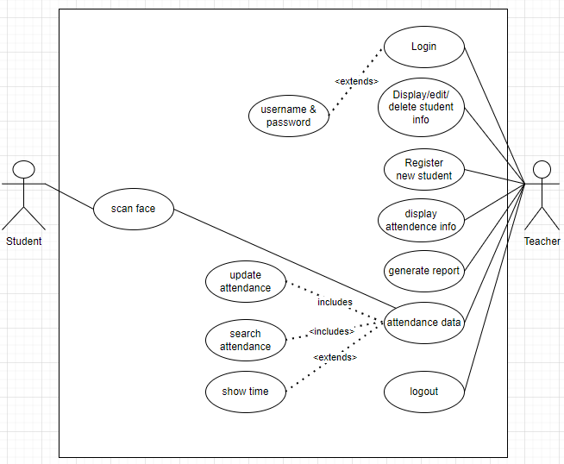

**Figure 4.2.1.1: Use Case Diagram 1**

As above Use Case Diagram show the roles of the two persons as an student and Teacher. Teacher have the authorities to manipulate in the system where student doesn't have authorities. There are many features like display, updating, deleting, login, logout, registration new student, generate report, attendance data, display attendance information and can access the system online. These are mostly required to complete the system.

1. Teacher can add or delete the student from the system as students by their id, name and class section.
2. When Teacher registered the students name as student, student’s face can be use to take attendance in the system.
3. Whenever the teacher have any problems regards update, they can change in the system communicate with supervisor about it.
4. If the teacher would like to leave the system from the connect device they would simply need to logout.

### Non-Functional Requirements

1. The user will inform the students when taking a photo with clear instructions on how to position their faces.
2. The system can detect the face from a live-stream video.
3. The system is reliable because of the advanced technology that is used to develop the system, the system can achieve a face detection accuracy of up to 90%.
4. The system will have a response time of many seconds.

## Feasibility Study

A feasibility study evaluates the project's potential for success. Therefore, perceived objectivity is an important factor in the credibility of the study for potential investors and lending institutions. . It must therefore, be conducted with an objective, unbiased approach to provide information upon which decisions can be based. Here, we discuss 3 major feasibility studies required for our project.

### Technical Feasibility

Technical feasibility is carried out to determine whether the project is feasible in terms of software, hardware, personnel, and expertise, to handle the completion of the project. It considers determining resources for the proposed system. As the system is developed using python, it is platform independent. Therefore, the users of the system can have average processing capabilities, running on any platform. The technology is one of the latest hence the system is also technically feasible.

### Operational Feasibility

Operational feasibility is the measure of how well a proposed system solves the problems with the users. Operational feasibility is dependent on human resources available for the project and involves projecting whether the system will be used if it is developed and implemented. The project is operationally feasible for the users as nowadays almost all the teachers/staffs are familiar with digital technology.

### Economic Feasibility

Economic feasibility defines whether the expected benefit equals or exceeds the expected costs. It is also commonly referred to as cost/benefit analysis. The procedure is to determine the benefits and the savings expected from the system and compare them with the costs. A proposed system is expected to outweigh the costs. This is a small project with no cost for development. The system is easy to understand and use. Therefore, there is no need to spend on training to use the system. This system has the potential to grow by adding functionalities for students as well as teachers. This can Hence, the project could have economic benefits in the future.

1. High Level Design of System

### Methodology of the proposed System

All the students of the class must be registered by administrator by entering the required details and then their images will be captured and stored in the datasets. During each session, faces will be detected from live streaming video of classroom. The faces detected will be compared with images present in the datasets. If match found, attendance will be marked for the respective student.

In software engineering, a software development methodology (also known as a system development methodology, software development life cycle, software development process, software process) is a division of software development work into distinct phases (or stages) containing activities with the intent of better planning and management. It is often considered a subset of the systems development life cycle. The methodology may include the pre-definition of specific deliverables and artifacts that are created and completed by a project team to develop or maintain an application.

Common methodologies include waterfall, prototyping, iterative and incremental development, spiral development, rapid application development, extreme programming and various types of agile methodology. Some people consider a life-cycle "model" a more general term for a category of methodologies and a software development "process" a more specific term to refer to a specific process chosen by a specific organization.

In my project I have used Agile methods for the development process which is easy to used and saves many times. Every errors can be maintain at the moments.

The meaning of Agile is swift or versatile."Agile process model" refers to a software development approach based on iterative development. Agile methods break tasks into smaller iterations, or parts do not directly involve long term planning. The project scope and requirements are laid down at the beginning of the development process. Plans regarding the number of iterations, the duration and the scope of each iteration are clearly defined in advance. Following are the phases in the Agile model are as follows:

1. ****Requirements gathering:**** In this phase, you must define the requirements. You should explain business opportunities and plan the time and effort needed to build the project. Based on this information, you can evaluate technical and economic feasibility.

****2. Design the requirements:**** When you have identified the project, work with stakeholders to define requirements. You can use the user flow diagram or the high-level UML diagram to show the work of new features and show how it will apply to your existing system.

****3. Construction/ iteration:**** When the team defines the requirements, the work begins. Designers and developers start working on their project, which aims to deploy a working product. The product will undergo various stages of improvement, so it includes simple, minimal functionality.

****4. Testing:**** In this phase, the Quality Assurance team examines the product's performance and looks for the bug.

****5. Deployment:**** In this phase, the team issues a product for the user's work environment.

****6. Feedback:**** After releasing the product, the last step is feedback. In this, the team receives feedback about the product and works through the feedback. [6]

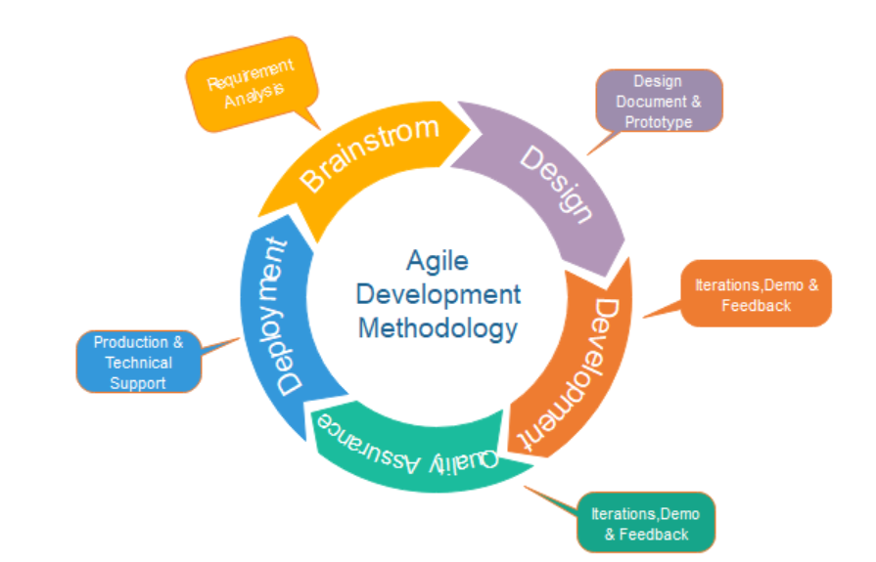

**Figure 4.4.1: Agile Methodology**

### Working Mechanism

The working mechanism behind a Face Recognition Attendance System is based on the use of facial biometric data to recognize individuals. This involves extracting features from an individual's face, such as their eyes, nose and mouth, which are then compared with stored templates or profiles of known faces using mathematical algorithms. If there is a match between these extracted features and those in a database of registered users, it can be concluded that the user has been recognized by the system. The accuracy of this process depends on the quality and quantity of training data used for registration, as well as any changes made to the appearance of a person over time (such as hair growth).

Typically this process can be divided into four stages,

**1. Dataset Creation**

Images of students are captured using a web cam. Multiple images of single student will be acquired with varied gestures and angles. These images undergo pre-processing. The

images are cropped to obtain the Region of Interest (ROI) which will be further used in recognition process. Next step is to resize the cropped images to particular pixel position. Then these images will be converted from RGB to gray scale images. And then these images will be saved as the names of respective student in a folder.

**2. Face Detection**

Face detection here is performed using Haar-Cascade Classifier with OpenCV. Haar Cascade algorithm needs to be trained to detect human faces before it can be used for face detection. This is called feature extraction. The haar cascade training data used is an xml filehaarcascade_frontalface_default. will be used for feature extraction. Here we are using detectMultiScale module from OpenCV. This is required to create a rectangle around the faces in an image. It has got three parameters to consider- scaleFactor,

minNeighbors, minSize. scaleFactor is used to indicate how much an image must bereduced in each image scale. minNeighbors specifies how many neighbors each candidate rectangle must have. Higher values usually detects less faces

but detects high quality in image. minSize specifies the minimum object size. By default it is (30,30) [7]. The parameters used in this system is scaleFactor and minNeighbors with the values 1.3 and 5 respectively.

**3. Face Recognition**

Face recognition process can be divided into three stepsprepare training data, train face recognizer, prediction. Here training data will be the images present in the dataset. They

will be assigned with a integer label of the student it belongs to. These images are then used for face recognition. Face recognizer used in this system is Local Binary Pattern

Histogram. Initially, the list of local binary patterns (LBP) of entire face is obtained. These LBPs are converted into decimal number and then histograms of all those decimal

values are made. At the end, one histogram will be formed for each images in the training data. Later, during recognition process histogram of the face to be recognized is calculated and then compared with the already computed histograms and returns the best matched label associated with the student it belongs to [8].

**4. Attendance Upgradation**

After face recognition process, the recognized faces will be marked as present in the excel sheet and the rest will be marked as absent and the list of absentees will be mailed to the respective faculties. Faculties will be updated with monthly attendance sheet at the end of every month.

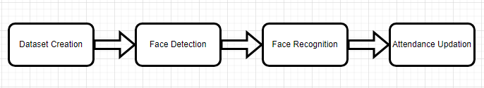

**Figure 4.4.2: working mechanism**

### Flow Chart

A flowchart is a picture of the separate steps of a process in sequential order. It is a generic tool that can be adapted for a wide variety of purposes, and can be used to describe various processes, such as a manufacturing process, an administrative or service process, or a project plan.

* To develop understanding of how a process is done
* To study a process for improvement
* To communicate to others how a process is done
* When better communication is needed between people involved with the same process
* To document a process
* When planning a project

#### Admin

Teachers are admin in my project, where they have many authorities. First of all teacher have to login into the system to access all features. As they get into the system, teacher can view the system. Some of them are given below:

1. Teachers have the authorities to register new students with their id, name, contact, roll no as well photo.
2. Teacher have to save their student’s face in the dataset for the auto attendance system by camera.
3. Teachers can view students information along with edit, delete and add features.
4. Teachers can view the attendance information of students and can delete it, if needed to.
5. Teachers can generate the attendance report with print features.

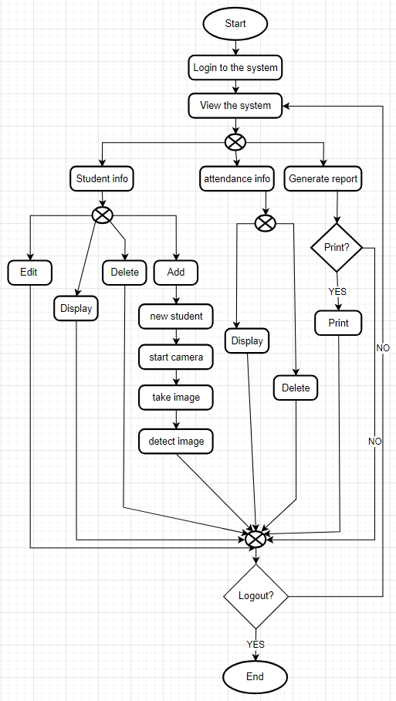

**Figure 4.4.3.1: Admin Flow Chart**

#### User

Students are user in my project. They don’t have any authorities as teachers have. They simply has to face towards the camera as to present their attendance in the college/school. Some of the things students have to do are:

1. Students have to enter the class and look at the camera then camera will take image.
2. Try to match the face saved in the dataset, If not match then display as absent.
3. If face is matched then it will check time and present their name in attendance if time is matched otherwise present as late.

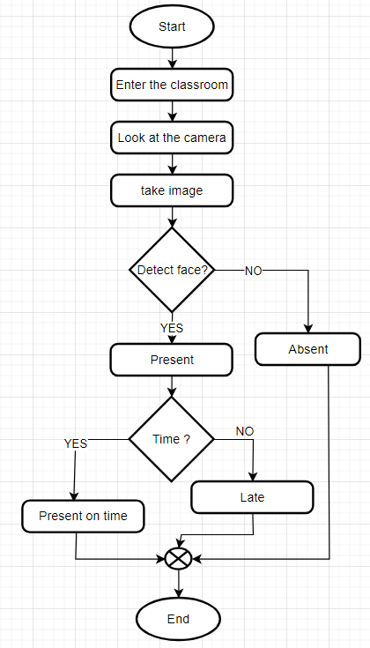

**Figure 4.4.3.2: User Flow Chart**

### Data Flow Diagram

It represent the system of different levels of abstraction. It have 3 levels. Started from level 0 to level 2. level 0 represent the system as a single process with its relationship to external entities. It shows entire system as a single bubble with inputs and outputs data indicated by arrows. level 1 represent the main functions of the system and breakdown the high-level of level 0 into sub process. Level 2 represent the one step deeper into parts of level 1 with functional and database storage. The following figures shows the level 0, level 1 and level 2 of DFD.

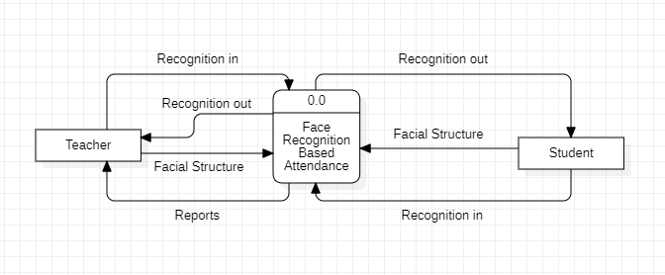

**Figure 4.4.4 : DFD Level 0**

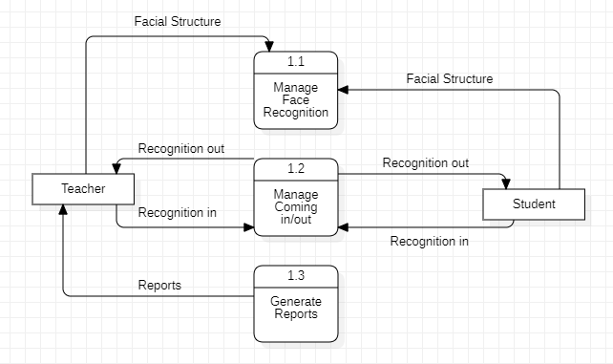

**Figure 4.4.4 : DFD Level 1**

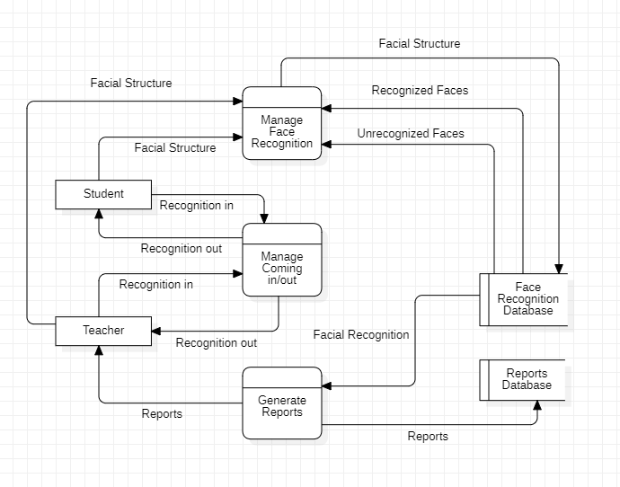

**Figure 4.4.4 : DFD Level 2**

1. **ER Diagram**

This ER diagram for a face recognition system depicts the various steps taken to develop a face recognition system. Below E-R Diagram shows the one to many and many to many relationship between the different entity table in the system. There are five entities which includes Teacher, Student, Face Records, Attendance Records and User Accounts. Even we have five entity in the E-R diagram, all are required to complete the system. Teacher entity contains seven attributes i.e, teacher id, user id, name, gender, email, address and record id. Teacher is the admin in the system. User Accounts entity contains four attributes i.e, user id, user type, username and password. This entity help teacher to login in the system if teacher name is match in User Accounts otherwise cannot access the system. Student entity contains five attributes i.e, student id, name, gender, roll no and contact. Teacher have authorities to add, delete and manipulate in student information. Face Record entity have to attributes i.e, face id and student id. It help to take image of student and to detect their face. Attendance Records entity have four attributes i.e, record id, record date, student id and face id.

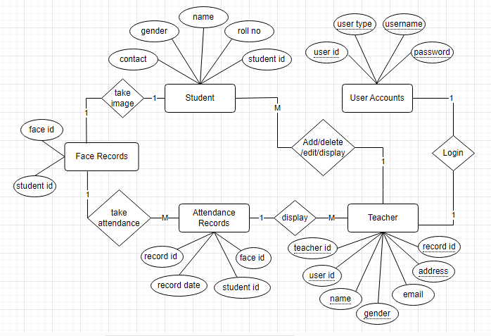

**Figure 4.4.5: ER Diagram 1**

### Description of Algorithm

Face recognition algorithms are made to recognize and verify people based on the characteristics of their faces. I'll give a broad overview of a common face recognition algorithm even though there are many different techniques and algorithms utilized in face recognition systems.

**Proposed Algorithm**

1. Capture the student’s image through camera.
2. Detect each and every individual face by apply face detection algorithm.
3. Extract the ROI(Region Of Interest) in rectangular bounding box.
4. Converting to gray scale, apply histogram equalization and resize to 100x 100 i.e. apply pre-processing.
5. If image captured then Store in database Else Apply LBPH (for feature extraction ) Apply SVM( for classification) End if
6. Post-processing

**Local Binary Patterns Histogram(LBPH) Step- by -step algorithm:**

1. **Parameters**: the LBPH uses 4 parameters:
2. **Radius**:

the radius is used to build the circular local binary pattern and represents the radius around the central pixel. It is usually set to 1.

1. **Neighbours**:

the number of sample points to build the circular local binary pattern. Keep in mind: the more sample points you include, the higher the computational cost. It is usually set to 8.

1. **Grid X**:

the number of cells in the horizontal direction. The additional cells, the finer the grid, the higher the dimensionality of the resulting feature vector. It is usually set to 8.

1. **Grid Y**:

the number of cells in the vertical direction. The more cells, the finer the grid, the higher the dimensionality of the resulting feature vector.

**Training the Algorithm:**

First, we need to train the algorithm. To do so, we need to use a dataset with the facial images of the people we want to recognize. We need to also set an ID (it may be a number or the name of the person) for each image, so the algorithm will use this information to recognize an input image and give you an output. Images of the same person must have the same ID.

**Applying the LBP operation:**

The first computational step of the LBPH is to create a intermediate image that describes the original image in a better way, by highlighting the facial characteristics. To do so, the algorithm uses a concept of a sliding window, based on the parameter’s radius and neighbours.

**Extracting the Histograms**:

Now, using the image generated in the last step, we can use the Grid X and Grid Y parameters to divide the image into multiple grids. [9]

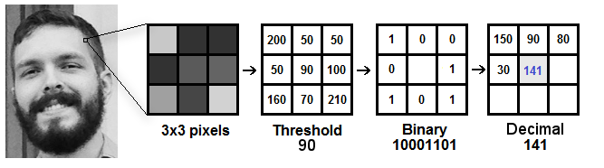

**Figure 4.4.6: LBPH Algorithm**

# Chapter 5: Gantt Chart

Gantt chart is a project management tool that illustrates work completed over a period of time in relation to the time planned for the work. A Gantt chart can include the start and end dates of tasks, milestones, dependencies between tasks, assignee, and more.

**Table 5: Gantt Chart 1**

|  |  |  |  |  |
| --- | --- | --- | --- | --- |
| **Gantt Chart** | | | | |
| **S.N** | **Task** | **Start Date** | **End Date** | **Duration** |
| 1 | Introduction | 27-Feb-2023 | 10-Mar-2023 | 11 Days |
| 2 | Background Study and Literature Review | 5-Mar-2023 | 16-Apr-2023 | 42 Days |
| 3 | System Analysis and Design | 22-Mar-2023 | 9-Apr-2023 | 18 Days |
| 4 | Implementation and Testing | 5-Apr-2023 | 26-Apr-2023 | 21 Days |
| 5 | Conclusion and Future Recommendations | 24-Apr-2023 | 19-May-2023 | 25 Days |

Above table shows the time period of the tasks. It took 11 days for introduction of the project. Similarly, for background study and literature review, it took 42 days, 18 days for system analysis and design, 21 days for implementation and testing and 25 days for conclusion and future recommendation.

**Figure 5: Gantt Chart 1**

On the left of the chart is a list of the activities and along the top is a suitable time scale. Each activity is represented by a bar; the position and length of the bar reflects the start date, duration and end date of the activity.

# Chapter 6: Expected Outcome

This system aims to build an effective class attendance system using face recognition techniques. The proposed system will be able to mark the attendance via face Id. It will detect faces via webcam and then recognize the faces. After recognition, it will mark the attendance of the recognized student and update the attendance record.

We have developed a system that automatically detects and recognizes students' faces and displays their information and whether he was registered or not. This would be possible by applying deep learning and image analysis algorithms to detect student's faces.

\

# References

1. *Sciencedirectassets.com*.[Online].Available:https://pdf.sciencedirectassets.com/
2. S. Dumpa, “Facial recognition attendance system using python and OpenCv,” 2020.
3. K. Senthamil Selvi, P. Chitrakala, and A. Antony Jenitha, “Face recognition based attendance marking system,” *Ijcsmc.com*. [Online]. Available: https://ijcsmc.com/docs/papers/February2014/V3I2201468.pdf. [Accessed: 03-Jun-2023].
4. *Researchgate.net*.[Online].Available:https://www.researchgate.net/publication/282241840_Fingerprint_Based_Attendance_System_Using_Microcontroller_and_LabView. [Accessed: 03-Jun-2023].
5. *Researchgate.net*.[Online].Available:https://www.researchgate.net/publication/282241840_Fingerprint_Based_Attendance_System_Using_Microcontroller_and_LabView. [Accessed: 03-Jun-2023].
6. “Agilemodel,”*www.javatpoint.com*.[Online].Available:https://www.javatpoint.com/software-engineering-agile-model. [Accessed: 03-Jun-2023].
7. “Medium,” *Medium*. [Online]. Available: https://becominghuman.ai/face-detection-using-opencv-with-haar. [Accessed: 03-Jun-2023].
8. “SuperDataScience,”*Superdatascience.com*.[Online].Available:https://www.superdatascience.com/blogs/opencv-face-recognition. [Accessed: 03-Jun-2023].
9. P. Singh, “Understanding Face Recognition using LBPH algorithm,” *Analytics Vidhya*, 12-Jul-2021. [Online]. Available: https://www.analyticsvidhya.com/blog/2021/07/understanding-face-recognition-using-lbph-algorithm/. [Accessed: 03-Jun-2023].